* Admin Page top right corner

“Welcome Master”

Calendar

Contacts (where we store contact emails)

Notes

Support emails? If possible

* Notifications (Categorised - Orders, Seller Requests,

Orders made (With a view button)

When a product goes OOS (admin Products only)

* 4 Squares

New Expense

Purchases

Capital

TBC

**Products**

* Add a bulk upload section

Where I can insert a spreadsheet of data and it will upload all results to the correct categories (Will send template)

* In Sellers products, if Admin deletes a product, can it automatically remove all Sellers products too. Example below:

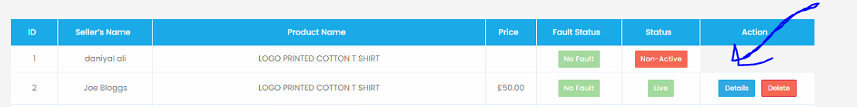

* When a sellers item is sold, there is an error in the layout



* Remove the function of having to approve sellers products

Both New & Pre-Owned. As they will be sent to us for authentication anyways.

**Orders**

* When admin deletes a product and previous orders have been made. Can you grey out the section. This is needed as we may need view previous orders despite product being deleted form the site

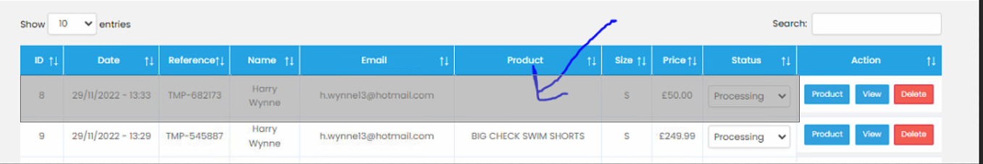

**News**

* When clicked in the news tab, can you add a column called “Section” after ID and will be either Featured, Top Trending, Most Recent, Other Articles

This will be selected by a drop down when adding a news article

**Wishlist**

* Can you remove the date, reference and status column
* In the action column can you add a view button which will take you to the product

**Settings**

* Please add an “Affiliate” sub tab (We’ve discussed previously)

Homepage Settings

* Please automate the top trending section based on sales for each gender

Coupon

* Please rename “Coupon” to “Discount”
* Please add an “Affiliate” sub tab (We’ve discussed previously)

Commission Settings

* Please remove all duplicates
* Please remove these 3 (not needed in this sections)

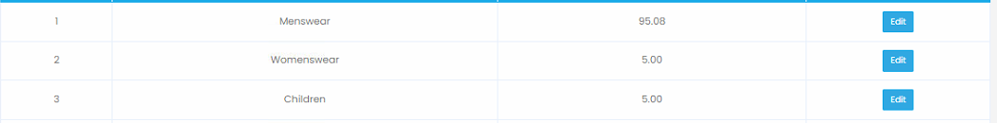

Sellers Payments

* Please ensure that the “Amount to pay” column reflects the commission percentage at that given time. Sometimes we may do promotions of No fees, so Amount to pay will be the same value as Selling price. Some days we may do 10% Commission fee, so Amount to pay will be 10% off selling price rather than 7.5%. But amount to pay must reflect the Commission fee AT THE TIME OF SALE
* Email Tab

Will list all people who sign up to the newsletter, prelaunch etc (if they unsubscribe it automatically takes their email off the list

* Size guide tab

(Mentioned in Front end feedback)

**Payment to us**

How do we receive payment?

Where does it go?

**Payment to Seller**

How is this going to work?